Global financial sales & Analysis

1. Project Overview and Objective
This project focuses on transforming raw data into actionable business insights through advanced data cleaning and preprocessing in Excel, followed by the development of an interactive Power BI dashboard for dynamic visualization and informed decision-making.

2. Data Sources
- Source Description and Timeline: https://learn.microsoft.com/en-us/power-bi/create-reports/sample-financial-download
- Domain: Sales Analytics

3. Problem Statement
- Cleaned and transformed raw datasets efficiently using Power Query

- Built dynamic Pivot Tables to perform in-depth sales analysis

- Conducted comprehensive year-wise sales trend analysis

- Evaluated month-wise performance patterns to identify seasonal trends

- Identified the top-performing country based on highest sales

- Designed compelling data visualizations and charts for clear business insights
4. Attribute (Column /Features) Details:
Attribute Name | Data Type | Description
Segment | Text (Categorical) | Customer segment category
Country | Text (Categorical) | County where the sales
Product | Text (Categorical) | Name of the product
Date | Date | Transaction date
Month Number | Numeric (Integer) | Month number
Month Name | Text | Month of the transaction
Year | Numeric (Integer) | Year of the transaction
Profit | Numeric (Decimal) | Profit earned
Sales | Numeric (Decimal) | Final sales amount
Gross Sales | Numeric (Decimal) | Total sales before discount
Units Sold | Numeric (Integer) | Number of units sold
Manufacturing Price | Numeric (Decimal) | Cost of manufacturing
Sales Price | Numeric (Decimal) | Selling price
COGS | Numeric (Decimal) | Cost of sold
Discount Band | Text (Categorical) | Discount category
Discounts | Numeric (Decimal) | Discount amount applied

5. Tools & Technologies
Microsoft Excel:
Data storage and organization, converting raw data into table format, Creating Pivot Tables, Performing Year-wise, Month-wise, Country-wise analysis and Creating charts for visualization
Power Query (Excel):
Data cleaning, handling missing values, transforming data, creating new columns (Year, Month Name), Removing duplicates and Data formatting
Pivot Table:
Aggregating sales data, Country-wise sales analysis, Year-wise comparison, Month-wise trend analysis, Percentage contribution analysis
Pivot Charts:
Visual representation of sales data, Country comparison charts, Year-wise performance visualization, Month-wise trend visualization
6. Data Pre-Processing (Excel / Power Query)
- Data Cleaning & Transformation: Removed duplicates, handled missing values.
- Data transformation: extracted year from data column, extracted month name from date column and structured the data for pivot table analysis.
- Pivot Tables: Created pivot tables and visualized using charts.

7. Data Modelling and DAX (POWER BI): Data Model
- The dataset was transformed into a star schema model by separating the data into fact and dimension tables.
- The dimension tables created include Dim Country, Dim Product, Dim Segment, and Dim Date, while the Fact table contains the sales transactions such as Sales, Profit, and COGS.
- Relationships were established between the fact table and dimension tables using primary and foreign keys to enable efficient data analysis.
- The dataset was transformed into a star schema model by separating the data into fact and dimension tables.
- The dimension tables created include Dim Country, Dim Product, Dim Segment, and Dim Date, while the Fact table contains the sales transactions such as Sales, Profit, and COGS.
- Relationships were established between the fact table and dimension tables using primary and foreign keys to enable efficient data analysis.

Screen shots of modelling:

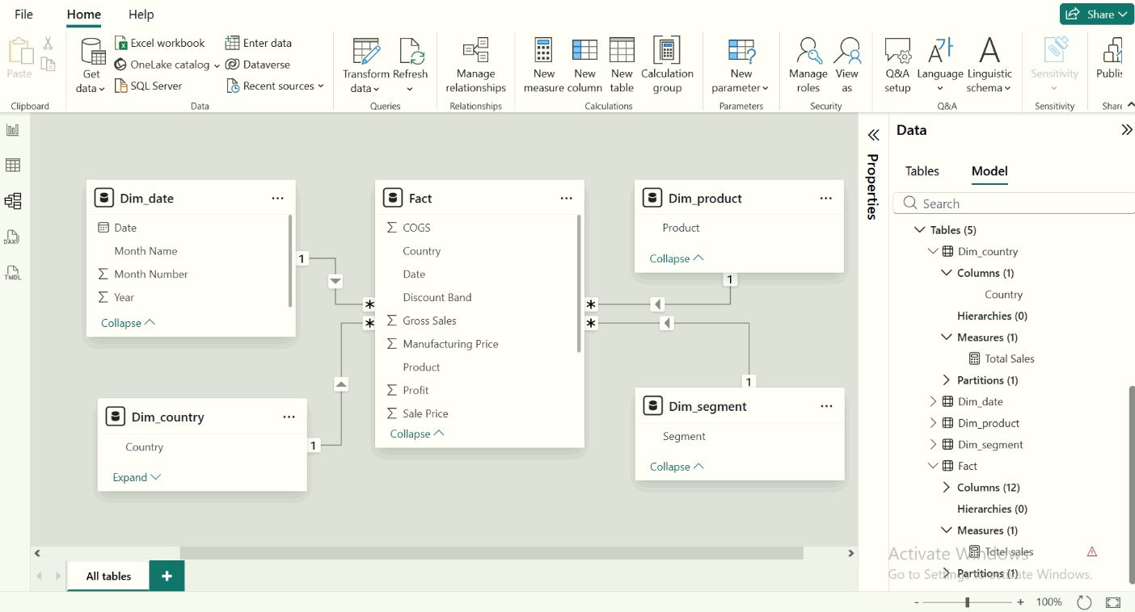
Calculated Columns & DAX Measures: DAX measures were created to calculate key business metrics.
The important measures implemented include:
* Total Sales = SUM (Fact [Sales])
* Total Profit = SUM (Fact [Profit])
* Profit Percentage = DIVIDE (SUM (Fact [Profit]), SUM (Fact [Sales]))
These measures help analyze the overall business performance and profitability.

8. Analysis and Visualization (POWER BI): Dashboard Features: Multiple visualization Based on Problem Statement:

- Bar Chart- Sales by country
This bar chart shows the sales distribution across different countries. It helps identify which country has the highest sales contribution.

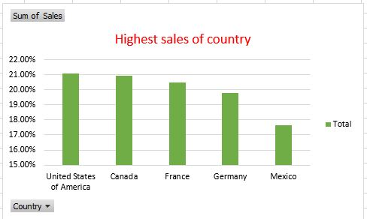

2. Pie Chart – Sales Percentage by Country
This pie chart represents the percentage contribution of sales from each country variations clearly.

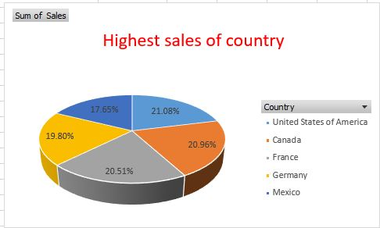

3. Clustered Column Chart This chart shows the monthly sales performance across different countries. It helps to analyze how sales vary from month to month in each country and identify the countries with higher sales performance.
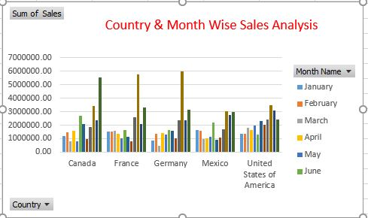

4.Line Chart This line chart represents the monthly sales trend across the year.
The chart helps to identify how sales change from month to month.
From the visualization, sales gradually increase during the middle of the year and reach a peak in the later months.
This analysis helps the organization understand seasonal sales patterns and make better business decisions.
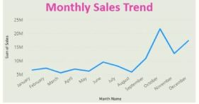 5.Card Total Profit This card shows the overall profit generated from the sales data.
It helps to quickly understand the total profitability of the business.
From the dashboard, the total profit is 16.89M, which indicates the company is generating a good margin from its sales.



6.Total Sales This card represents the total sales value generated across all countries and products.
It provides a quick overview of the company’s total revenue.
The total sales shown in the dashboard is 118.73M, which reflects the overall business performance.

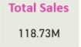

7. Country Slicer:
The slicer is used to filter the dashboard based on the selected country.
It allows users to view sales and profit data for a specific country.
This interactive feature helps in better analysis and comparison between different countries.

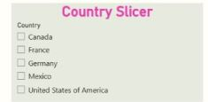

9. Insights & Conclusions:
Key Findings
- The United States of America recorded the highest overall sales contribution (around 21%).
- Canada and France followed closely with strong sales performance.
- Mexico showed comparatively lower sales contribution among selected countries.
- Sales show fluctuations across different months, indicating seasonal trends.
- Certain months recorded peak sales across multiple countries, suggesting high demand periods.
Provide the Analysis Insights
- Descriptive Analysis
- Total sales were distributed across five countries.
- The United States contributed the highest percentage of total sales.
- Monthly sales varied across countries, with visible peak and low-performing months.

- Diagnostic Analysis
- Higher sales in specific countries may be due to stronger market presence or higher demand.
- Monthly fluctuations suggest seasonal business patterns.
- Lower performance in some regions may indicate limited market penetration.

- Predictive Analysis
- If current trends continue, the United States is likely to remain the top-performing country.
- Seasonal sales peaks may repeat in similar months in upcoming years.
- Countries with moderate performance may show growth with strategic improvements.
- Prescriptive Analysis
- Focus marketing and sales strategies on high-performing countries to maximize revenue.
- Implement improvement strategies in lower-performing regions like Mexico.
- Plan inventory and promotions according to seasonal peak months.
- Analyze customer behavior in top-performing countries to replicate success in other regions.
10. Conclusion
- This project focuses on analyzing sales data using Excel and Power BI. The dataset was cleaned and organized using Excel, and dimension and fact tables were created for proper data modeling.
- Power BI was used to build interactive dashboards and visualizations such as bar charts, line charts, and KPI cards to analyze sales and profit performance.
- From the analysis, we can observe sales distribution across different countries and monthly sales trends. The dashboard also helps in identifying high-performing regions and understanding overall business performance.
- This project demonstrates how data visualization tools like Power BI can help businesses make better data-driven decisions.

